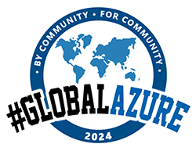

Melbourne 2024 Sponsor Pack

Introduction – Global Azure Bootcamp

Since the very first Global Azure Bootcamp, organised over ten years ago, what is now known as Global Azure has gone from strength to strength. Three days where enthusiasts, professionals, students and community leaders around the world come together to share their knowledge, experience, and passion for the Microsoft Azure cloud.

We are excited to announce that the ***Melbourne Global Azure 2024*** will take place ***Saturday 20th of April!*** You can also be part of the largest global community event for Azure technology on the planet!

Global Azure 2023 by the numbers was impressive: ***483 speakers***delivered ***445 sessions*** at 110 events organised by ***105 communities.*** Thousands of people in the Azure community around the globe joined either in person or online.

During the bootcamp, Microsoft & GitHub product group members, partner evangelists, MVP’s and real-world customers explore the latest Microsoft technologies in a single day. After a physical hiatus through the Covid pandemic, this event returns to an in-person format for 2024 in Melbourne Australia.

This sponsorship program is about informing IT vendors on the possibilities the Bootcamp offers for showcasing your services and solutions to visitors during this event.

“There is no better way to learn about Azure than from the community of Azure enthusiasts at the Global Azure event.”

**Scott Guthrie**

**EVP Cloud and AI, Microsoft**



Azure Bootcamp 2024 in figures

The Melbourne edition of the Global Azure Bootcamp will take place on April 20th at RMIT Universities illustrious Storey Hall.  
  
To have an idea of what the event entails, below you will find a summary of the event.

* One local community: <https://melbourneazurebootcamp.com>
* During the day, three parallel tracks
* More than 20 breakout-sessions
* More than 25 experts / Microsoft Most Valuable Professionals
* Over 200 attendees
* Upwards of 20,000 online impressions via digital channels
* More than 72 hours #GlobalAzure trending topic on twitter
* Lead generation at the event.

**View Here:**Website (Local): <https://melbourneazurebootcamp.com>

Website (Global): <https://globalazure.net>

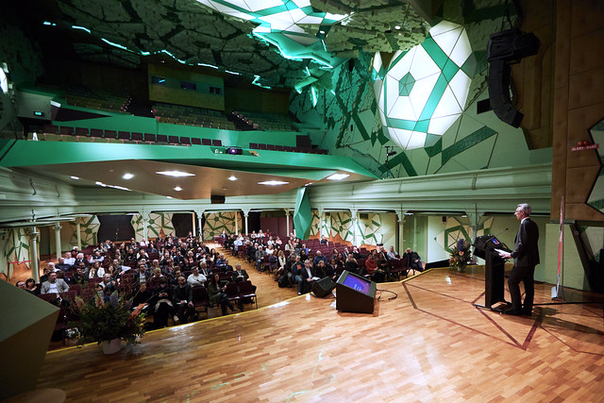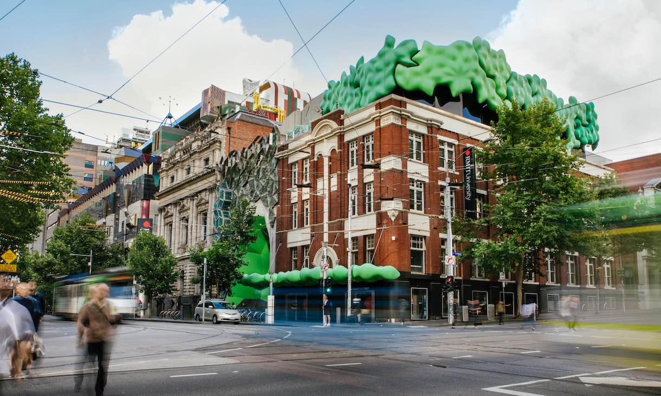

## Melbourne 2024 Agenda

Planning for the 2024 event is already well underway, with our Call for Speakers (CFS) receiving over 50 submissions from local, national, and international participants.   
  
Our current program* is as follows.

|  |  |  |  |
| --- | --- | --- | --- |
| **Time** | **Main Lecture Hall** | **Green Brain, Room 1** | **Green Brain, Room 2** |
| 8:30am | Check-in & Arrival | | |
| 9:00am | Event Welcome | | |
| 9:30am | Session 1 | Session 2 | Session 3 |
| 10:30am | Session 4 | Session 5 | Session 6 |
| 11:30am | Session 7 | Session 8 | Session 9 |
| 12:30pm | Lunch | | |
| 1:30pm | Session 10 | Session 11 | Session 12 |
| 2:30pm | Session 13 | Session 14 | Session 15 |
| 3:30pm | Afternoon Tea | | |
| 3:50pm | Session 16 | Session 17 | Session 18 |
| 4:50pm | International Guest Speaker – Diversity & Inclusion | | |
| 5:30pm | Q&A Panel & Event Close | | |
| 6:00pm | Event Finishes | | |

* The program is subject to change based on speaker availability, scheduling and other influencing factors

Sponsor Packages 2024

The Melbourne edition of the Global Azure is a free, non-profit event run for the benefit of the local technical community. In 2024 we are seeking sponsorship to facilitate operating costs such as Venue hire, catering and security.

The bootcamp offers three (3) sponsorship packages. This sponsorship package offers you the ability to show services and solutions to the visitors during this event. At the event square you can show your services and solutions in a relevant way. Additionally, it provides the opportunity to network and socialize with participants, speakers, partners, user groups and other interested.

|  |  |  |  |  |
| --- | --- | --- | --- | --- |
|  | **Diamond** | | **Platinum** | **Gold** |
| Booth Space at the event | ✓ | ✓ | |  |
| A breakout Session in Sponsor Rooms | ✓ |  | |  |
| Logo Placement on event Lanyard | ✓ |  | |  |
| Logo Placement/Solution in slide during sessions and in online recordings | ✓ | ✓ | | ✓ |
| Logo on the Melbourne Azure Bootcamp Website | ✓ | ✓ | | ✓ |
| Listing in slides during the opening keynote | ✓ | ✓ | | ✓ |
| **Cost** | AUD $2000 | AUD $1000 | | AUD $500 |

Due to the non-profit nature of the bootcamp, sponsorship amounts may be partially refunded should the event operate under-budget.

## Sponsorship Agreement

|  |  |
| --- | --- |
| **Event Sponsor:** |  |
| **Address:** |  |
| **City, State, ZIP Code:** |  |

## **Subject:** Event Sponsorship Agreement

## Dear,

## This agreement (the "Agreement") is made between Melbourne Azure Bootcamp ("Event Organizer") and [Event Sponsor] ("Sponsor") on this [Date] for the sponsorship of the [Event Name] (the "Event"), scheduled to take place on 20th April 2024 at RMIT Storey hall, Building 16 336/348 Swanston St, Melbourne VIC 3000.

**Sponsorship Package:**

The Sponsor agrees to sponsor the Event at the ______________ level (select the package below). The

sponsorship package includes the following benefits:

|  |  |  |  |  |
| --- | --- | --- | --- | --- |
| **Global Azure 2024 Sponsorship Package** | **Diamond** | | **Platinum** | **Gold** |
| **Cost** | AUD $2000 | AUD $1000 | | AUD $500 |
| **Package Selection** | [ ] | [ ] | | [ ] |

**Sponsorship Fee:**

In consideration of the Sponsorship Package, the Sponsor agrees to pay the Event Organizer a sponsorship fee of ______________ (AUD) no later than 30/03/2024. Payment shall be made via Bank Deposit.

**Sponsor's Obligations:**

The Sponsor agrees to fulfil the following obligations:

1. Provide the Event Organizer with the Sponsor's logo and any relevant marketing materials within 2 weeks
2. after signing the agreement.
3. Cooperate with the Event Organizer regarding any promotional activities related to the Event.
4. Comply with all applicable laws and regulations while participating in the Event.

**Event Organizer's Obligations:**

The Event Organizer agrees to fulfil the following obligations:

1. Display the Sponsor's logo prominently on all marketing materials, including but not limited to event website, banners, flyers, and social media promotions.
2. Acknowledge the Sponsor's contribution during the Event, such as mentioning the Sponsor's name during speeches or presentations.
3. Should the event operated under forecasted budget, provide refunds to Sponsors, calculated on a pro-rata basis, with each sponsor receiving a percentage % refund of any surplus aligned to their individual sponsorship contribution. E.g. Diamond Sponsor, Contoso’s investment makes up 40% of the total sponsorship budget. After operating costs, the event runs with a surplus of $520.00. Contoso is refunded 40% of this surplus ($208.00).
4. Melbourne Azure Bootcamp is an event about Microsoft Technologies and integrated products. Sessions and Booth must adhere to Microsoft technologies related topics, including products within Microsoft 365 and Azure or products that integrates with Azure or O365.

**Intellectual Property:**

The Sponsor acknowledges that all intellectual property rights related to the Event, including but not limited to trademarks, copyrights, and patents, are the sole property of the Event Organizer. The Sponsor shall not use the Event Organizer's intellectual property without prior written consent.

**Termination:**

Either party may terminate this Agreement by providing written notice to the other party. In the event of termination, the Sponsor will remain responsible for any payment obligations incurred before the termination date.

**Confidentiality:**

Both parties agree to keep all confidential information obtained during the course of this Agreement confidential and not to disclose it to any third parties without prior written consent.

**Governing Law and Jurisdiction:**

This Agreement shall be governed by and construed in accordance with the laws of Victoria, Australia. Any disputes arising under or in connection with this Agreement shall be subject to the exclusive jurisdiction of the courts of Victoria, Australia.

**Entire Agreement:**

This Agreement constitutes the entire agreement between the parties and supersedes all prior discussions, understandings, or agreements, whether written or oral, relating to the subject matter herein.

Please indicate your acceptance of the terms and conditions outlined in this Agreement by signing and returning a copy to us no later than [Signature Deadline]. If you have any questions or require further clarification, please do not hesitate to contact us.

We look forward to a successful collaboration and an outstanding Event.

Sincerely,

Azure Bootcamp Melbourne

**Accepted and agreed:**

|  |  |  |
| --- | --- | --- |
| **Sponsor Name :** | |  |
| **Sponsor Title:** | |  |
| **Date:** |  | |

Melbourne 2024

Melbourne 2024 Sponsor Pack